Dynatrace Monitoring System
Requirement:
- Ec2 instance (Flipkart)
- Dynatrace
Tasks –
Install logs and observe
Add custom log
- Create alert for cpu ram etc
- Create dashboards
- Create workflow with pagerduty
- Create an ec2 instance (Flipkart) and login as root user .
Add host/server .
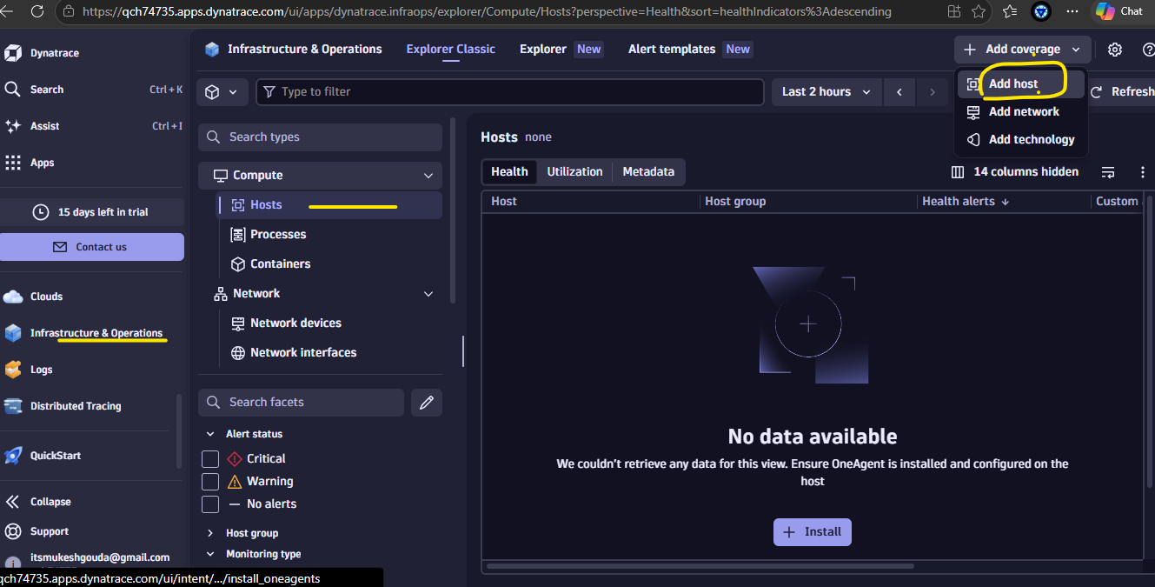
Select operating system and architecture : linux & x86
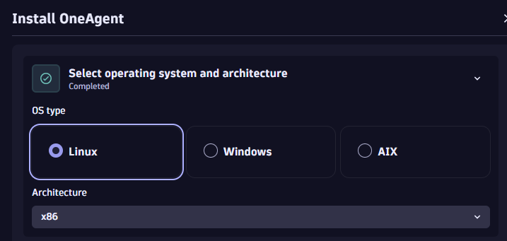

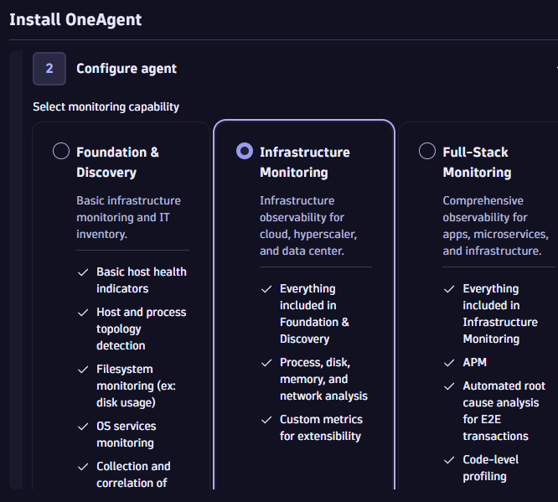
Generate key and install the agent downloader in ec2 and verify .
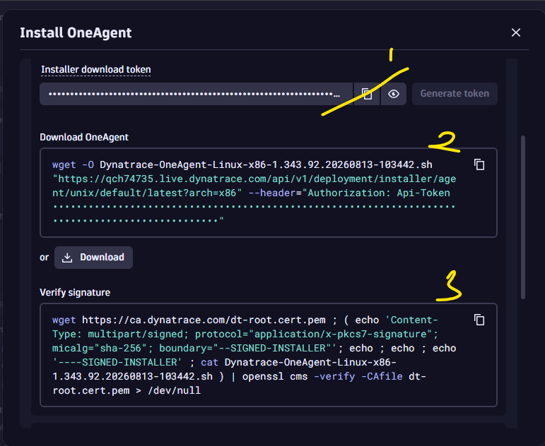

Install the agent
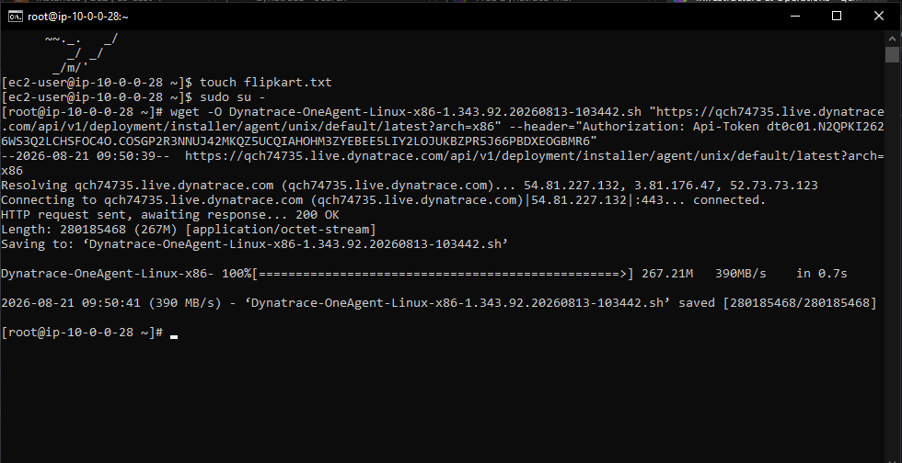

Verify
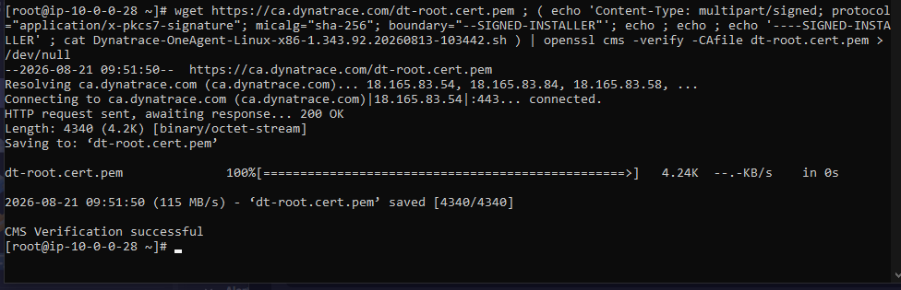

Now install the- OneAgent:
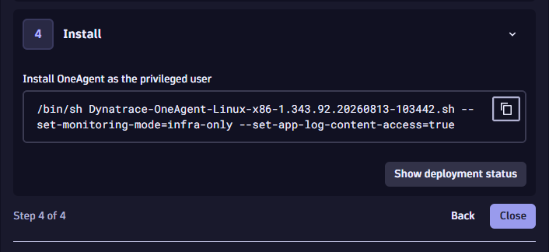
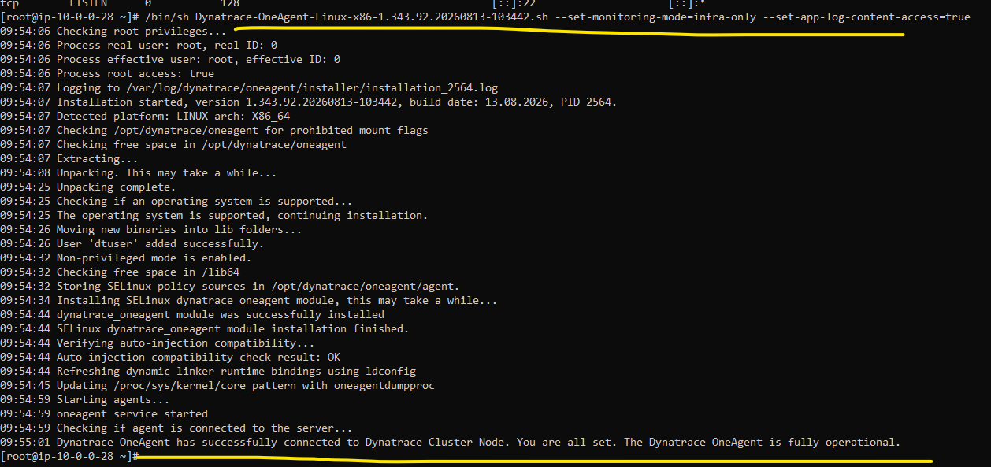
#systemctl start oneagent
# systemctl status oneagent

Now refresh the page and check the metrics
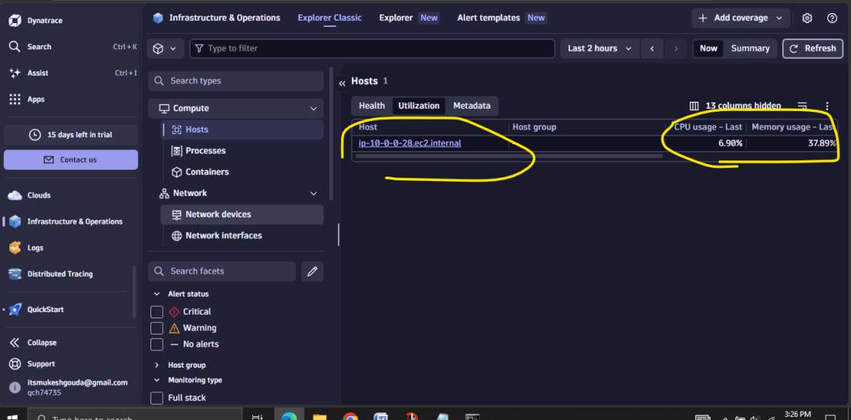
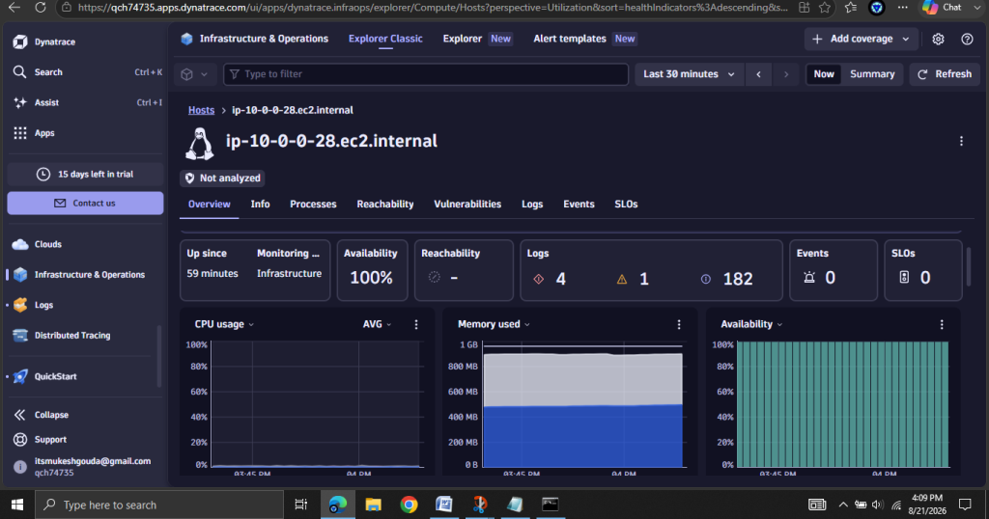

Now increase the load using stress command .
#yum install stress –y -> install the stress package
# stress –version
Stress the CPU: To stress 4 CPU cores for 10 seconds:
#stress -c 4 --timeout 10
Stress Memory: To stress memory with 2 workers, each allocating 128MB, for 10 seconds:
stress --vm 2 --vm-bytes 128M --timeout 10

Combine CPU and Memory Stress:
stress -c 4 --vm 2 --vm-bytes 128M --timeout 5
Stress Disk: To stress disk with 2 workers writing 1GB each:

stress --hdd 2 --hdd-bytes 1G --timeout 10

Now increase the stress for 300 s
#stress -c 4 --timeout 300
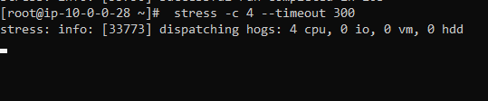
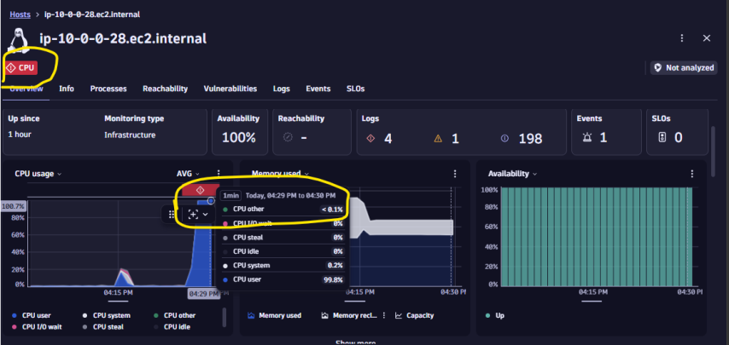

You can check logs of the instance
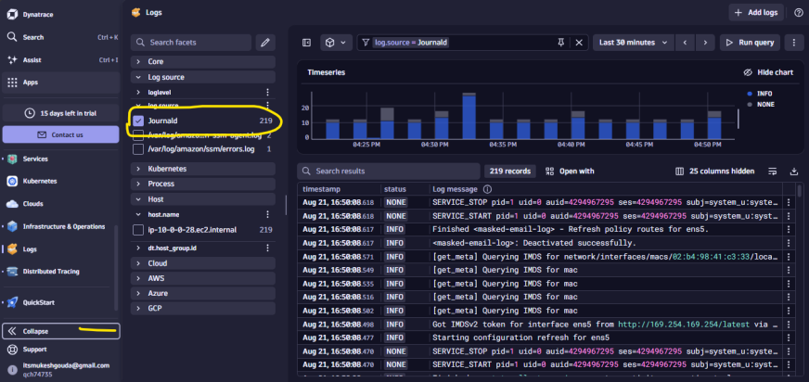

Now try to install httpd service and observe if the logs stored or not .
#yum install httpd –y
#systemctl start httpd
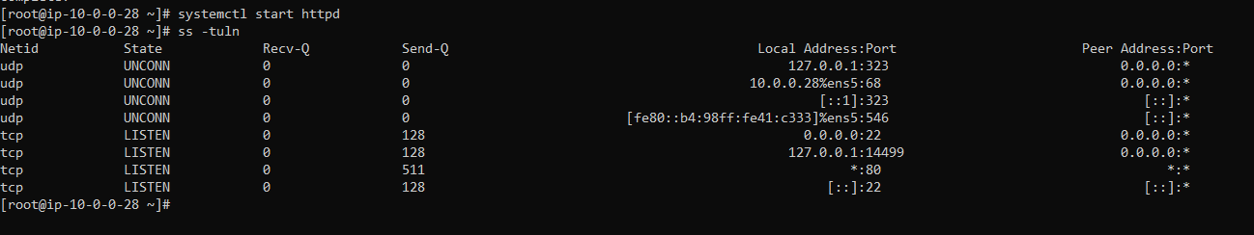
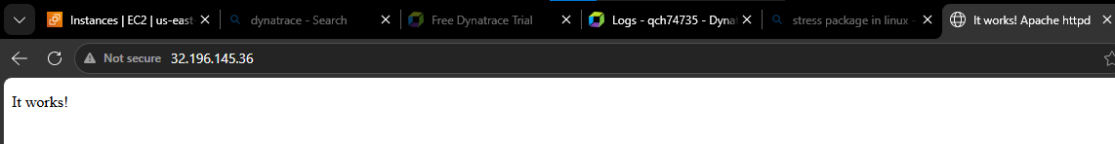

One agent automatically detect the log file and show the logs
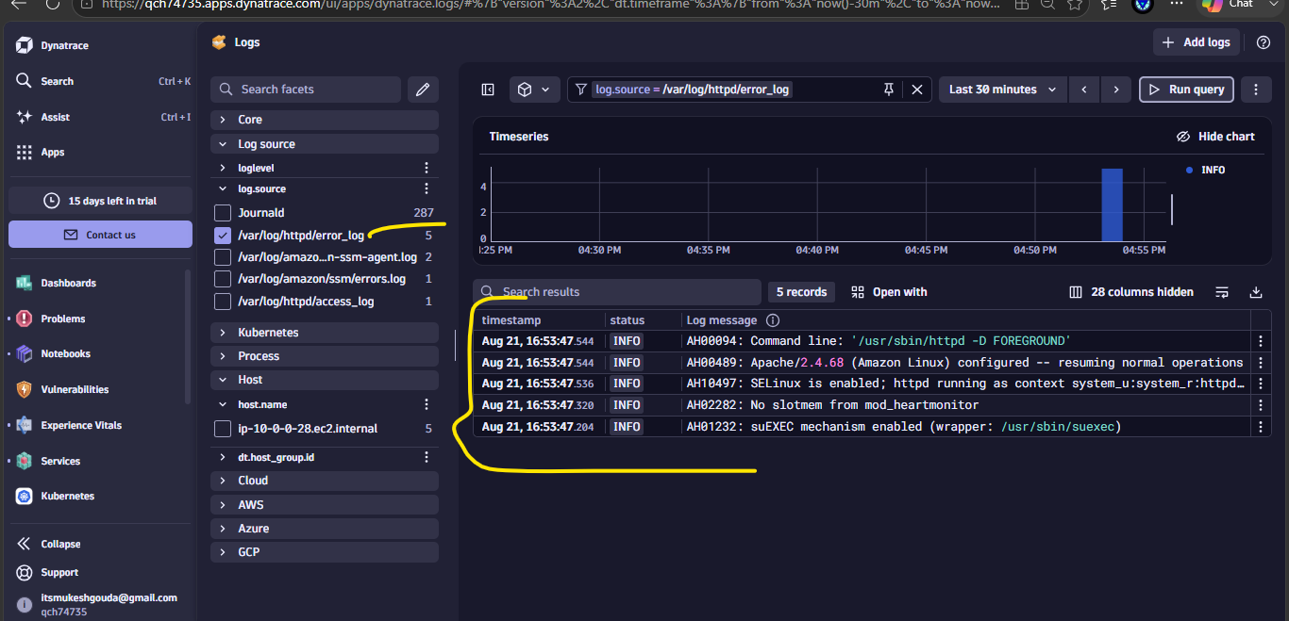

We can also configure custom log file to track .
Create a .log file and add the path in the dynatrace
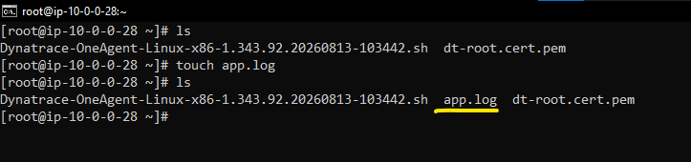
Search settings
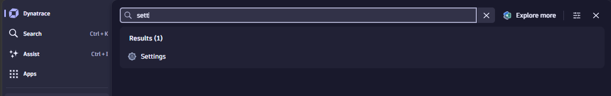
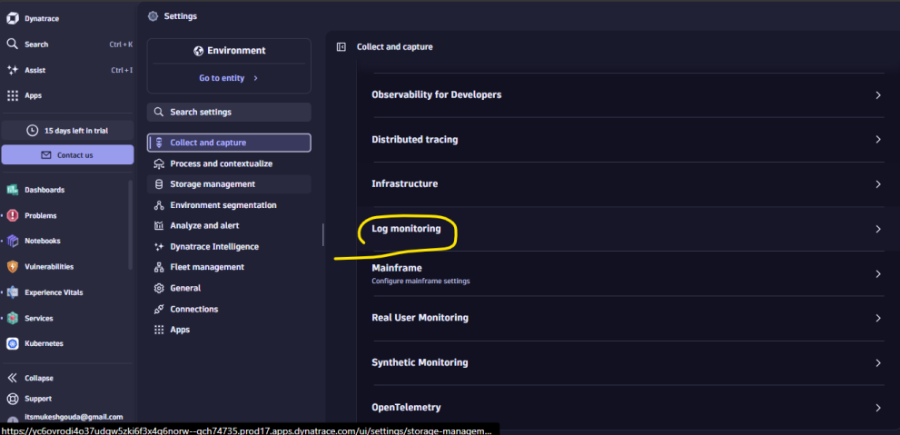
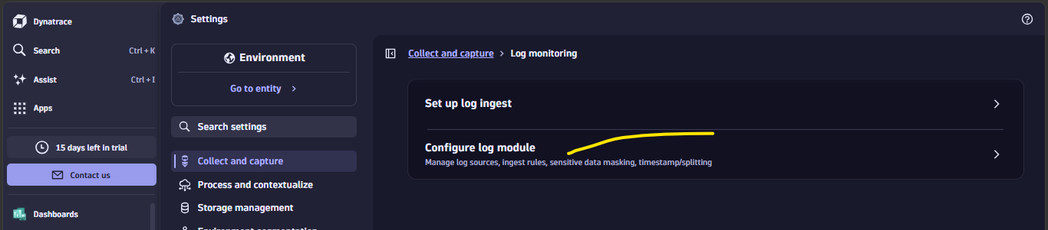
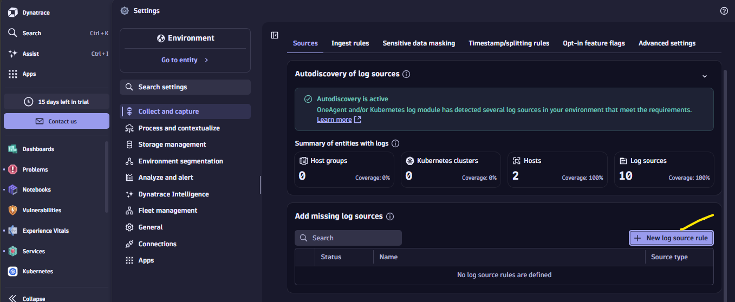
Give log folder and and path
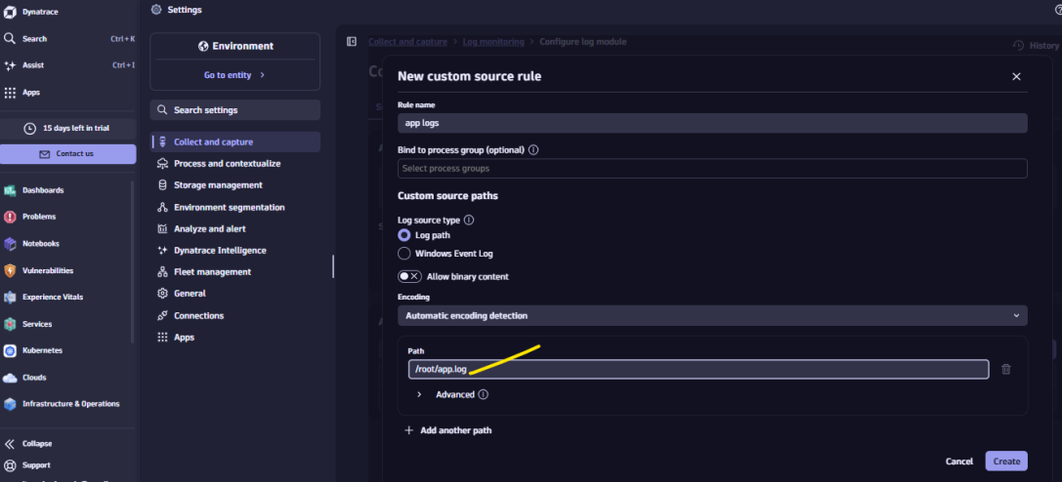

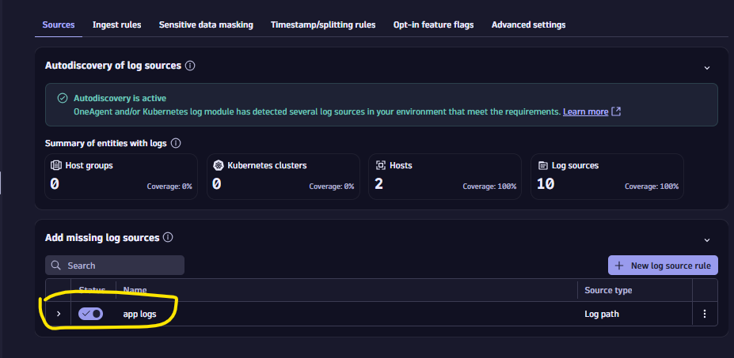

Create alert for server cpu
Go to search >Anomalyy Detection > create alert
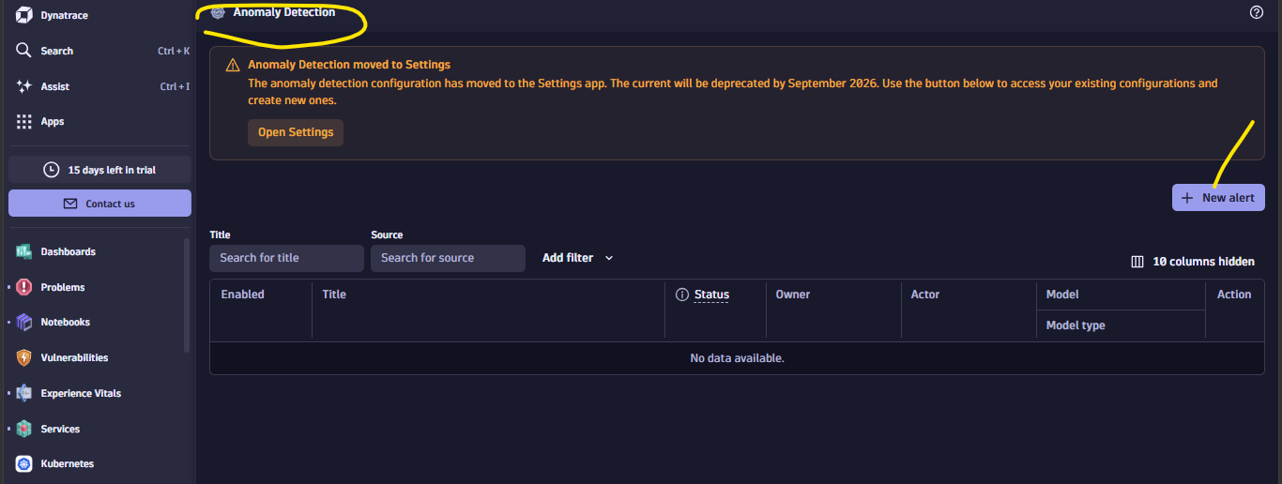
Set alert details
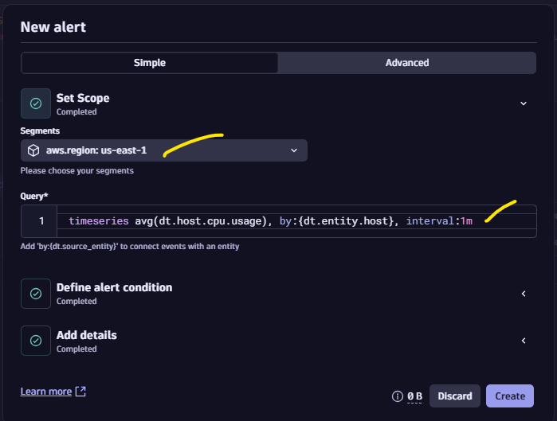
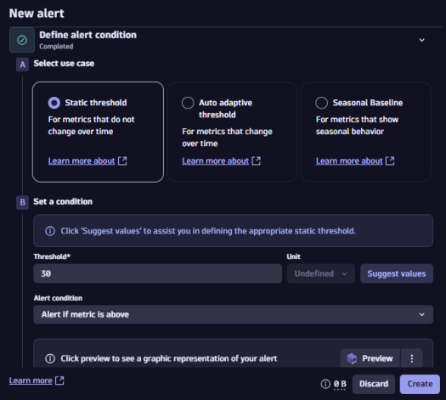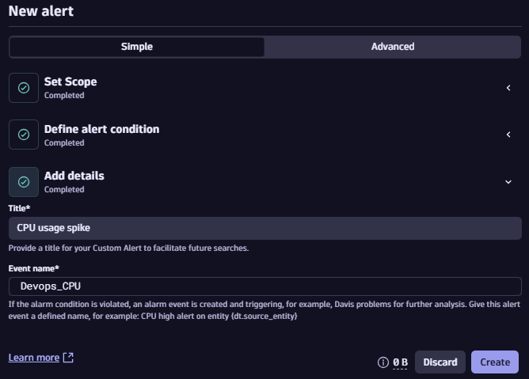
Wait till status shows success
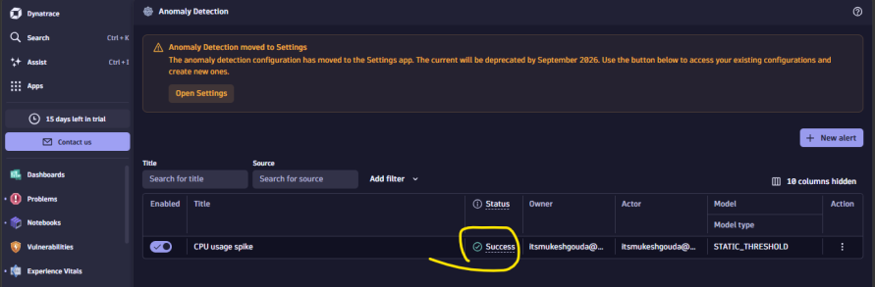
Now login to ec2 and intentionally increase the cpu load
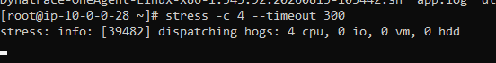
Now go to problem tab and filter active alerts . [Make sure you are selecting the host depoyed zone ]
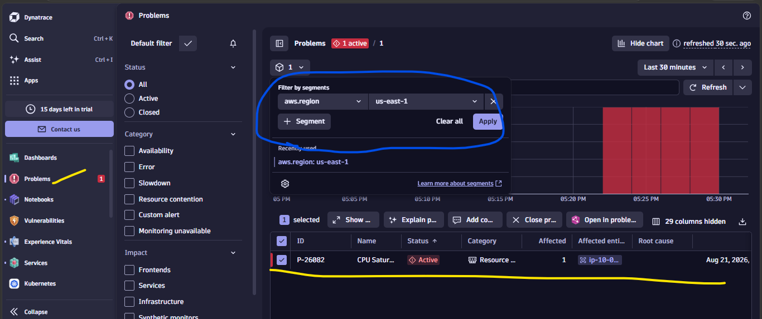

We can also make our custom dashboard like grafana :
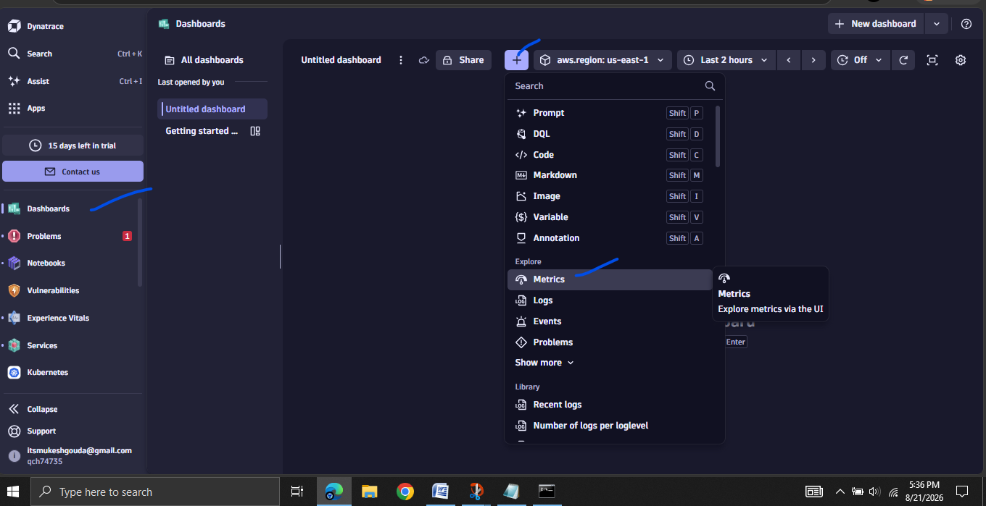

Create alert for cpu
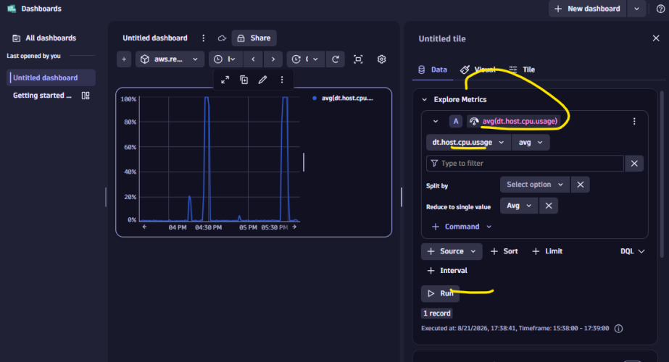

Dynatrace workflow for Pagerduty
We can make a workflow so that the pager duty will trigger an event when any event or incident create
First create a connection
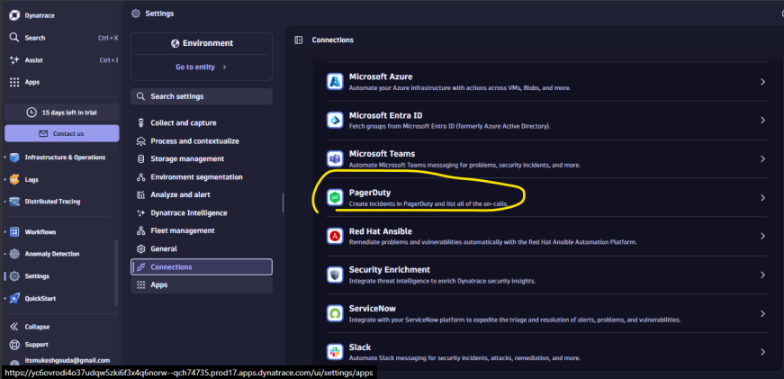
By giving url and token it will create a connection
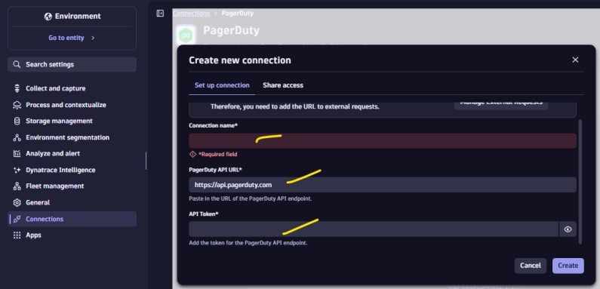
Later in workflow you can give connection name and event information it will trigger an incident.
